Name: SkillSynth AI
GITHUB url: https://github.com/SreePavani1103/project_space-/tree/main
SkillSynth AI is a personal career assistant. It combines your resume, GitHub, and LeetCode stats. Then, it compares them to real tech job descriptions.
Description:
SkillSynth AI is a privacy-first, personal placement copilot designed to help students transition from chaotic job searches to a structured, data-driven skill-building journey. By aggregating user data across uploaded resumes, GitHub repositories, and LeetCode statistics, the platform semantically match a candidate's profile against real-world job descriptions. Based on this 360-degree intelligence, the system delivers actionable, end-to-end preparation tools, including proficiency radar charts for skill gaps, ATS-focused resume optimizations, curated learning materials, and AI-generated smart coding questions targeted specifically at the user's weak areas. Built entirely without the need for custom training or data storage, the platform ultimately empowers students to clearly identify their shortcomings, learn smarter, and get hired faster.
Project Scope: SkillSynth AI (Prototype Version)
Note on Prototype Scope:
This version of SkillSynth AI is a functional prototype (MVP). It prioritizes core logic—such as RAG-based role matching, PDF parsing, and GitHub/LeetCode integration—using stable, curated datasets to demonstrate the platform's accuracy and potential before moving to live-scraping or external OAuth production environments.
Functional Requirements
User Authentication: User Authentication: Secure user access using standard email and password authentication along with GitHub OAuth login, implemented with Flask-Login and cryptographically signed session cookies for secure session management, ensuring safe and authenticated user sessions.
User Profiles & Data Collection: Automated parsing and extraction of skills and history from uploaded resumes (PDF/DOCX formats), alongside synced public profile data from GitHub and LeetCode.
Curated Job Market Data: Uses a high-quality, pre-defined static knowledge base of tech job descriptions and industry keywords to ensure consistent, reliable matching logic and role analysis during the prototype phase.
Core Matching Engine (RAG): A Retrieval-Augmented Generation (RAG) scoring system that calculates job fit, semantically comparing user profiles against target roles to highlight specific skill gaps.
AI-Driven Skill Recommendations: Identifies technical weaknesses and generates structured learning paths, conceptual explanations, and coding challenges integrated directly within the AI output report.
Resume Optimization: Automated keyword checks and specific improvement tips to help users better format their resumes for automated ATS filters.
Report Export: Compiles the comprehensive gap analysis, scoring, and recommendations into a downloadable PDF report for the user.
Non-Functional Requirements
Security & Privacy: Implementation of standard security protocols, including password hashing and secure token-based routing, to protect user data and ensure secure access.
Speed & Performance: Codebase is optimized for responsive execution, ensuring a smooth user experience during the heavy computation of resume parsing, AI evaluation, and profile data fetching.
Scalability & Architecture: Built with a modular service-based architecture (separating routing, AI logic, and data parsing) to allow for easy scaling and addition of future live-scraping features.
Usability: Features a mobile-friendly design, accessible interface (WCAG 2.1 AA compliant), and student-friendly error messaging for seamless navigation.
Reliability: High system stability through decoupled service design, ensuring consistent performance of core analysis engines even if external profile fetches (like LeetCode) experience delays.
AI Accuracy: Strict system prompting to ensure all AI-generated advice and gap analyses are grounded exclusively in the user's factual resume and profile data, preventing AI hallucinations.

The Problem
Engineering students face big challenges when looking for jobs:
- Blind Applications: Students apply to many jobs without knowing if they are a good fit.
- Unclear Skill Gaps: Students do not know what specific skills they need to learn next.
- Disconnected Practice: Students solve random coding problems without a clear goal.
- Hidden Achievements: Students solve many problems on coding sites (like LeetCode) and build projects (on GitHub), but struggle to show this real-world proof clearly to recruiters.

- Missing the "Big Picture": Students often apply to jobs just because they know a basic keyword (like "Python"), without understanding the deeper technical skills the company actually wants.

- Scattered Profiles: A student's professional identity is spread out—resumes in one place, code in another. There is no single place to check their overall "readiness score" for a job.

- Outdated Preparation: The tech job market changes very fast. Students don't have a way to check if their current skills are matching what companies are asking for today.

- No Clear "Next Steps": Even when a student gets rejected or knows they lack a skill, they aren't told exactly what to do next—like which specific project to build or which code to practice to fix the gap.
- Too Much Manual Work: Trying to manually find skill gaps and rewrite resume points for every single job application is exhausting and leads to mistakes.

The Solution
- Unified Professional Profile: SkillSynth AI automatically brings all of a student's scattered technical data together. It parses their uploaded resume and syncs it with their real-world proof on GitHub and LeetCode to create one complete picture.

- Smart "Big Picture" Matching: Instead of just looking for basic keywords, the platform uses advanced AI (RAG) to understand the deep meaning behind a student's projects and compares it directly to what the job actually requires.

- Clear "Job Fit" Score: Students instantly get a simple, easy-to-understand percentage score showing exactly how ready they are for a specific role, completely removing the guesswork from job applications.

- Actionable Next Steps: When the AI finds a missing skill, it doesn’t just point out the problem. It gives the student a specific, personalized learning roadmap—including exact coding concepts to study and practice.

- Data-Driven Preparation: By using a high-quality database of current tech job requirements, students can stop guessing and be confident they are learning the exact skills the industry wants right now.

Technologies Used
- Frontend: HTML , Css, JavaScript
- Backend & API: API Gateway, Python microservices (Flask/FastAPI)
- AI & Data: RAG for checking job matches, Resume reading tools ,AI models (Gemini/OpenAI), GitHub API, LeetCode API
- Database & Storage: Chroma database (chromaDB) , SQ Lite

System Architecture
Frontend (Client Layer)
- The responsive web interface where students view their dashboard, access practice questions, upload resumes, and log in securely.
- Key Additions: Handles real-time progress bars during AI analysis and manages secure JWT (JSON Web Token) storage for user sessions.
Backend (API Layer)
- The central traffic controller (built with Python/Flask) that routes user requests to the correct internal microservices.
- Key Additions: Includes specific service modules (e.g., resume_service.py, rag_service.py) to keep the codebase modular and scalable.
AI Engine (The Brain)
- The core system utilizing the Gemini API that semantically reads resumes, matches skills to job requirements, and generates personalized practice content.
- Key Additions: Implements a Retrieval-Augmented Generation (RAG) pipeline to ensure all AI advice is grounded in factual job market data rather than hallucinated answers.
Data & Integration Workers
- Background programs and API modules that safely fetch and sync new data from GitHub, LeetCode, and job boards without slowing down the main website.
Storage & Persistence (The Missing Layer)
- Relational Database (SQL): Stores structured user profiles, authentication details, and long-term progress metrics.
- Vector Database: (Crucial for your RAG implementation) Stores mathematical representations (embeddings) of job descriptions and resumes, allowing the AI Engine to perform deep semantic similarity searches instantly.
- Object Storage: Securely saves uploaded PDF/Word resumes and the generated PDF analysis reports.
- Cache: Temporarily stores frequently accessed data (like static job profiles) to ensure the system remains fast and responsive under heavy loads.

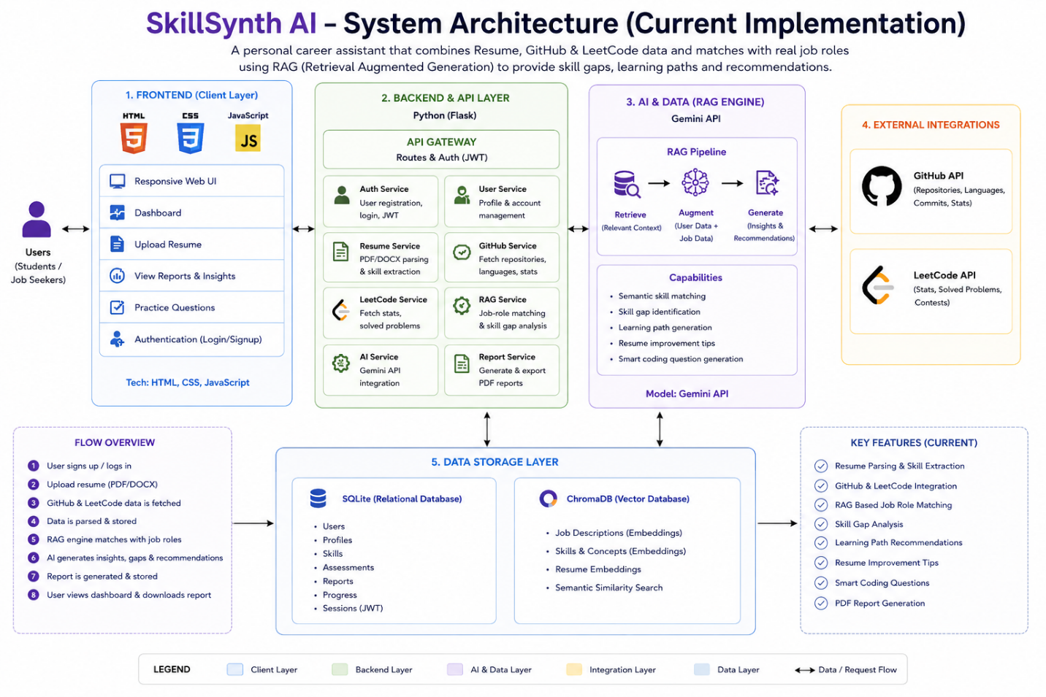

In Scope :
Profile Data Parsing: Extracting skills and history from uploaded resumes (PDF/DOCX) and syncing with public GitHub and LeetCode metrics.
Curated Role Analysis: Using a stable, pre-defined static knowledge base of tech job descriptions to reliably find required industry skills.
RAG-Based Matching: Calculating a precise "Job Fit Score" and finding specific skill gaps using a Retrieval-Augmented Generation (RAG) AI engine.
AI-Driven Recommendations: Generating personalized learning paths and conceptual coding challenges based on the user's identified weak points.
Secure Dashboard & Session Management: Building a functional user dashboard secured by standard email/password authentication (JWT sessions), including secure logout and session timeouts.
Data Privacy & Deletion: Providing users the ability to delete their uploaded documents and clear their account data from the system.
Graceful Error Handling: Implementing user-friendly error messages and system fallbacks for unsupported file uploads or third-party API limits.
Report Generation: Compiling all scores, gaps, and recommendations into a downloadable PDF report.

Out-of-Scope :
Live Web Scraping: Real-time crawling of external job boards (e.g., Internshala, LinkedIn, Glassdoor) is excluded in favor of our curated, static role database to ensure system stability and predictable AI analysis during the prototype phase.
- Live Code Execution: While the platform generates custom coding questions and templates to address skill gaps, it will not include a built-in IDE or compiler to execute or grade the user's live code.
- Automated Job Applications: The system provides comprehensive readiness analysis, job fit scoring, and resume optimization, but it will not automatically submit applications to job portals on the user's behalf.
- Direct ATS Integrations: The platform analyzes resumes for ATS compatibility using AI, but it does not directly plug into enterprise ATS software (like Workday or Greenhouse) via APIs.

Future Enhancements
1. Architecture & AI Intelligence
- Transition to Dynamic RAG: Evolving the rag_service.py to replace the current static ROLE_KNOWLEDGE_BASE with a dynamic retrieval system powered by the existing ChromaDB infrastructure.
- Semantic Analysis Upgrade: Moving beyond basic keyword matching in skill_gap_service.py to deep NLP-based semantic matching for higher accuracy in identifying related technical concepts.
- Advanced Authentication: Building upon the existing GitHub OAuth implementation to include Google and LinkedIn SSO for a more seamless user onboarding experience.
2. Ecosystem & Data Automation
- Live Job Ingestion: Building a scraping infrastructure to aggregate real-time job descriptions from platforms like LinkedIn, Indeed, and Internshala to replace curated datasets.
- Full Multi-Platform Sync: Expanding data connectors beyond GitHub and LeetCode to include HackerRank, GitLab, and Codeforces metrics for a true 360-degree professional profile.

Conclusion
SkillSynth AI replaces blind job applications with a data-driven strategy by combining a student's resume, GitHub, and LeetCode into one unified profile. Using advanced RAG AI, it compares this profile directly against industry job descriptions to instantly identify exact technical skill gaps. Ultimately, the platform empowers students with targeted learning roadmaps and automated resume fixes to confidently land competitive tech roles.

Project Type: SaaS WEB-APPLICATION

